|  |  |  |
| --- | --- | --- |
| Member 1 | Nabh Sanjay Mehta | NSM190002 |
| Member 2 | Anil Kumar Yadav Kare | Axk190056 |
| Class | BUAN 6312.003 | Thursday 4-7PM batch |

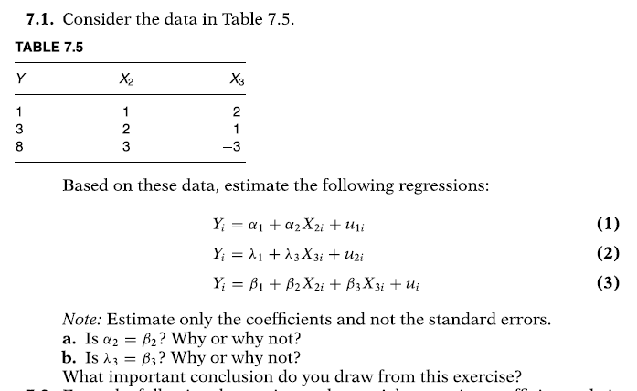

**Ans:**

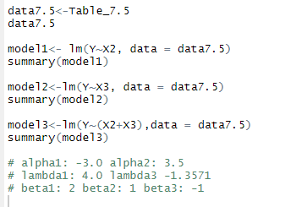

1. **Model 3 seems to be a true model and α2 seems to be a biased estimator of β2**
2. **Alpha 3 seems to be a biased estimator of β3**

**Conclusion: If we do not specify equation properly, then there are high chance of introducing errors and biases in the model and its estimations**

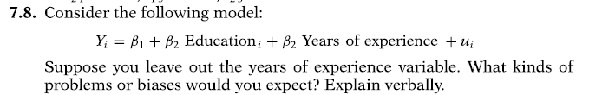

**Ans: If we remove X3(experience) and only keep X3(Education) in the equation then we might introduce some sort of biasness in a case where there seems to have a correlation between X2 and X3 variables.**

**The biasness will be accumulated in error term (u) which will not give enough information to the analyst or statistician on the causality of the bias.**

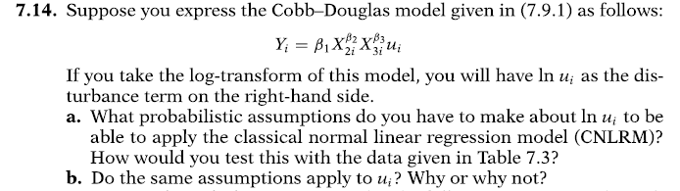

**Ans:**

**Part a) From textbook we will use assumption as below:**



**Part b) No, as per textbook, stochastic error term (u) must follow log-normal distribution with**

* 1. mean *eσ*2*/*2 and
  2. variance *eσ*2 (*eσ*2 − 1)*.*

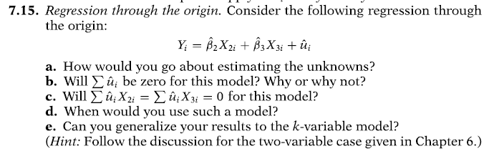

**Ans a**:

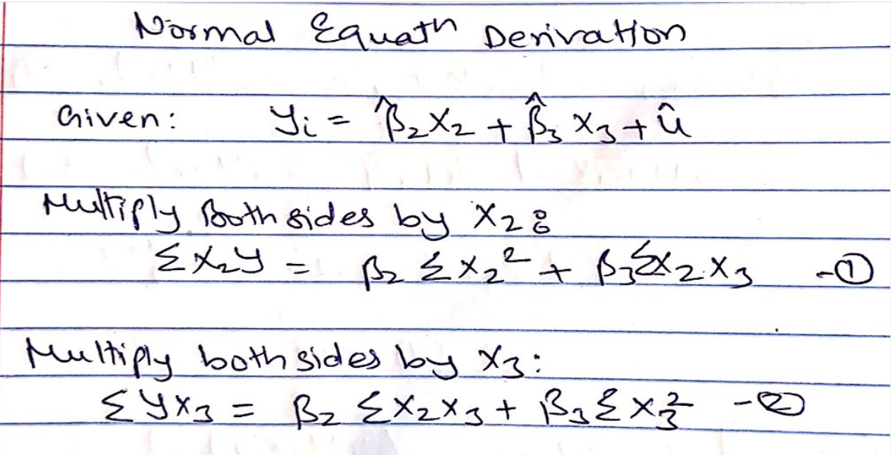

**Ans b: This is a regression equation that passes through origin, so Sum of residuals or error term (u) will not be Zero.**

**Ans c: No. same reason as in answer b.**

**Ans d: Conventionally, the coefficient of determination r^2 derived for this equation will not be meaningful. We will use this model only when there is a strong underlying theory to support it. Otherwise it is better to introduce intercept in the model equation.**

**Ans e: normalized equation in answer a is already generalized enough. We do not need to express it in terms of k.**

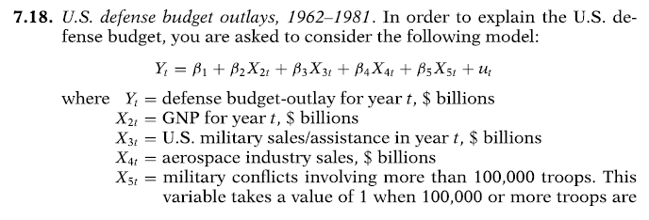

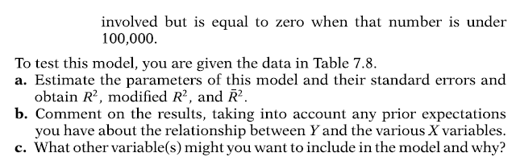

**Ans a:**

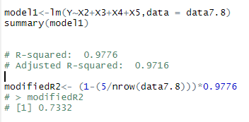

**Formula for modified R^2 from textbook:**



**Ans b:**

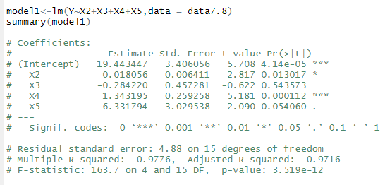

**Results are as per expectations, except X5, all other explanatory variables are significant at 5%.**

**Variables have positive effect on Y except for X3 and Armed conflicts have maximum toll on the defense budget as I have assumed.**

**Ans c: I would like to observe some form of seasonality since we are also dealing with sales of defense arms, which might have seasonality for example every year when government budget is released, they might want to allocate certain portion for defense purchases which could lead to ups and downs in the sales.**

**We can observe or visualize nice trends if we had those variables in the data.**

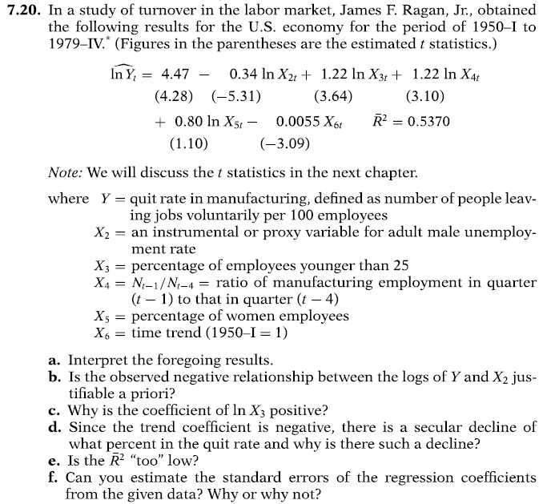

**Ans a: From the model summary given:**

**1% change in male unemployment rate leads to 0.34% decrease in quitting rate in manufacturing sector.**

**1% change in young hires leads to 1.22% change in quitting rate.**

**1% change in employment ratio leads to 1.22% change in quitting rate.**

**1% change in women employees leads to 0.80% change in quitting rate.**

**And 1% change in time trends leads to 0.55% change in quitting rate.**

**Ans b:**

**It requires a close look at the given observation. Unemployment rates and quitting rates are supposed to be negatively related to each other. You can have quitting rate if people are employed. How can we have a quitting rate when people are not even employed.**

**Ans c: Younger population who are hired have higher tendency to quit jobs for multiple reasons for ex. Joining new company for better pay, quitting to pursue higher education etc.**

**Although we are not commenting about the causation, we can always have a safe assumption which is supported by the results here.**

**Ans d: Again, we will not be commenting on the causation here. However, our assumption here is, over a period, employee perks and benefits have increased. Companies want high performing individuals to retain and this is what the trend has suggested us for the decline.**

**Ans e: Ideal R^2 shall be 70% and above as expected by the statisticians and analysts. However, this will be a relative term if it supports our story/theory.**

**Ans d: Off-course yes. Formula for t-stat <- Beta parameter/standard Error**

**So Standard Error <- Beta/t-stat. Beta & t-stat values are given in question so we can easily find it out.**

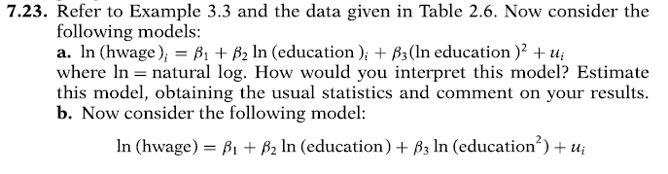

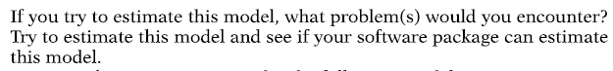

**Ans a:**

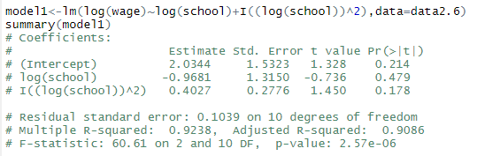

**This is a double log model.**

**1% change in education (School) leads to 0.96% decrease in wages. However, this decrease will diminish faster as the level of education increases, suggested by ‘I((log(school))^2)’ term.**

**Ans b:**

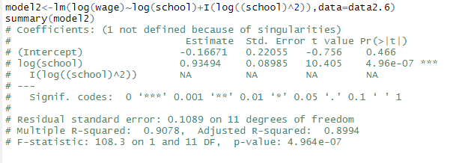

**We get NA for I(log((school)^2)) term and we are unable to get any estimates for it. Seems to be a problem of multicollinearity.**

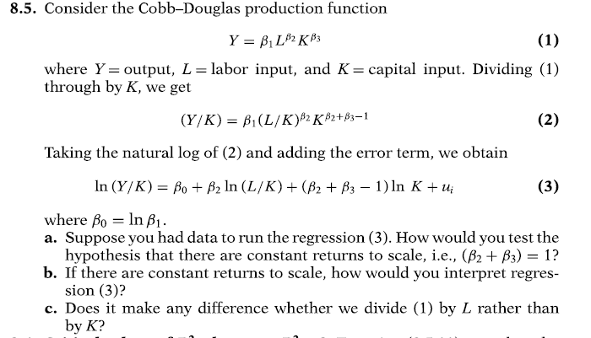

**Ans a:**

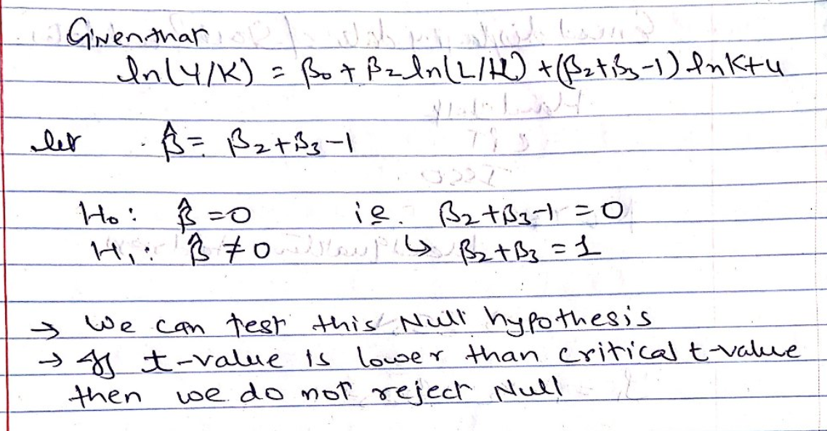

**Ans b: The interpretation would be for Y variable – ln(Y/K) and Explanatory variable ln(L/K) is:**

**A % change in Labor/Capital ratio leads to % change in Output/Capital ratio.**

**Ans c: The interpretation of Y variable – ln(Y/L) and explanatory variable ln(K/L) is:**

**A % change in capitol/labor ratio leads to % change in Output/Labor ratio.**

**Conclusion: It depends on company to company on how they want to track the performance whether it is based on Output/capital or Output/Labor ratios.**

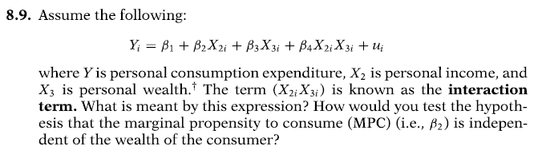

**Ans:**

**Taking derivatives to find the rate of change in consumption based on personal income and personal wealth.**

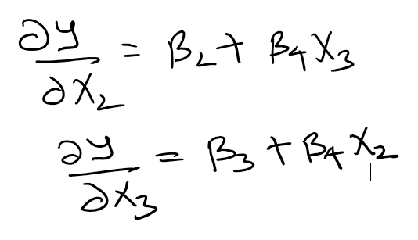

**As we can see rate of change of consumption with respect to personal income also depends on X3 i.e. personal wealth.**

**Similarly, in second derivative equation, rate of change in consumption with respect to personal wealth also depends on X2 i.e. personal income.**

**MPC (Beta 2) will be independent only when Beta 4 term is zero.**

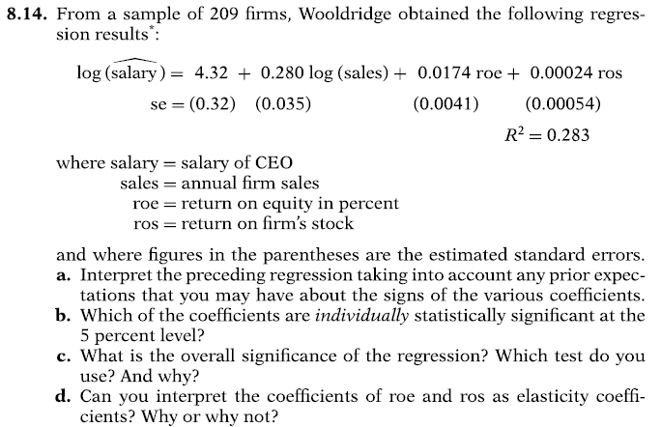

**Ans a:**

**1% change in annual firm sales leads to 0.28% change in salary of CEO**

**1-unit change in return on equity leads to 0.01% change in salary of CEO**

**1-unit change in return on firm’s stock leads to 0.02% change in salary of CEO**

**All variables have positive impact on the salary of CEO**

**Ans b: We can use the formula t-stat <- Beta/SE and find out here that values are 13.5,8,4.25,0.44.**

**Higher value tells us that they variables are highly significant.**

**Ans c:**

**We find F stat <- R^2/(k-1)/[(1-R^2)*(n-k)] = 27.02, where k = 4 and n = 209**

**The p value for such an F value is very small leading to rejection on null**

**And d: Since Salary is in log form and roe and ros are in linear form, we can say that they are in semi-elastic form. 1-unit change in roe and ros leads to % change in salary of CEO**

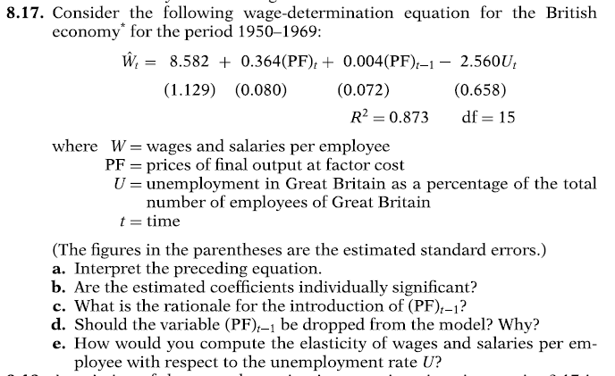

**Ans a:**

**1 unit change in PF leads to 0.36 unit change in Wages(W)**

**1 unit change in PF in previous year leads to 0.004 unit change in W**

**1 unit change in unemployment ratio leads to a decrease of 2.5 units in Wages**

**Ans b:**

**To find out significance, we need to check the t-stat values of it which are 4.55, 0.05, -3.89. 0.05 is not significant**

**Ans c: I think they wanted to check if previous year’s PF had any compounding effect on Wages.**

**Ans d: Since its T -stat value is 0.05 which is not significant, we can drop this variable from our model.**

**Ans e:**

**Formula to calculate elasticity is:**

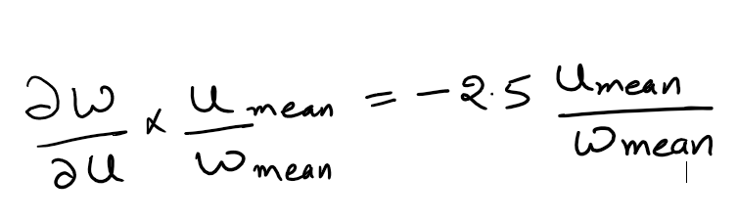

**-2.5 here is derived from coefficient of U**

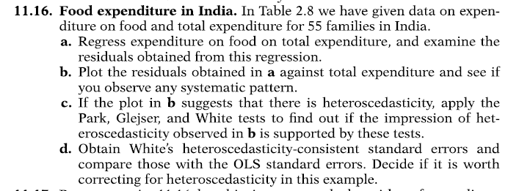

**Ans a:**

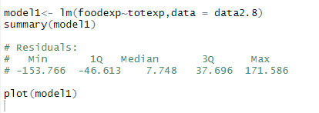

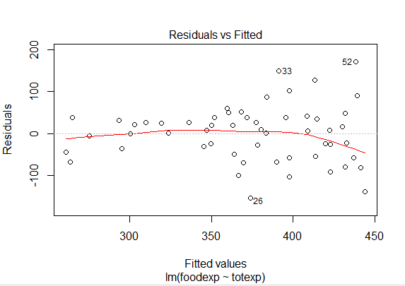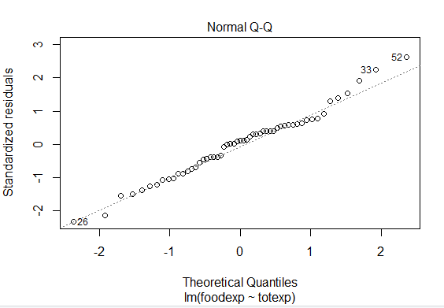

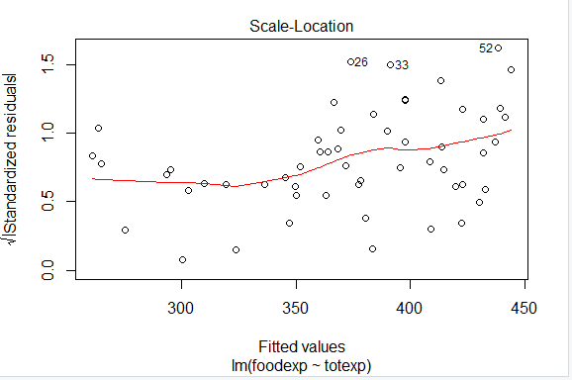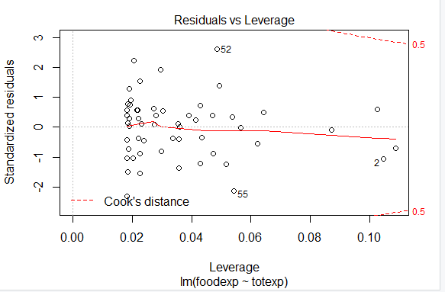

**Ans b:**

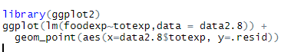

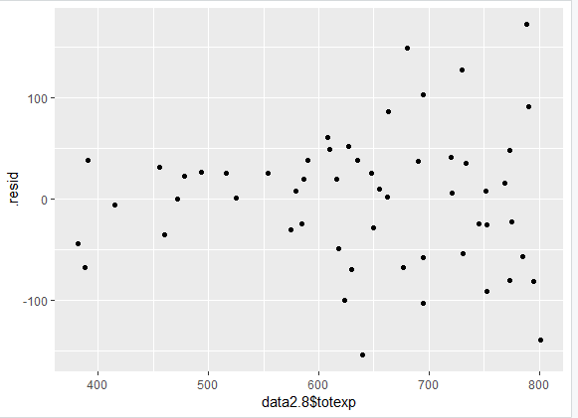

**Ans c:**

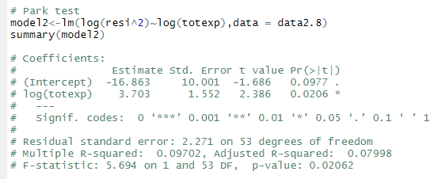

**Here slope is significant at 5% so we can confirm heterosdk.**

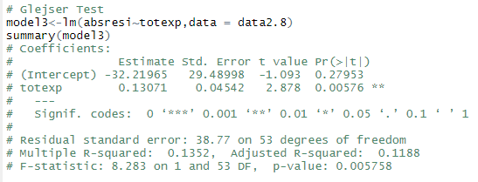

**Here slope is significant at 1% so we can confirm heterosdk.**

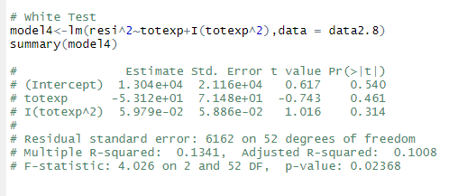

**Multiplying 55 with R-squared: 0.1341, we get value 7.37. If we get a chi-sq distribution, we get a p-value of 0.025 which is significant to reject null and suggests that there is heteroSDK.**

**Ans d:**

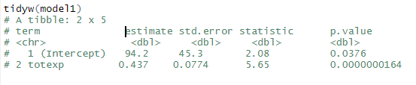

**If we compare this with summary of model 1 then we do not see much difference in Standard Errors reported.**

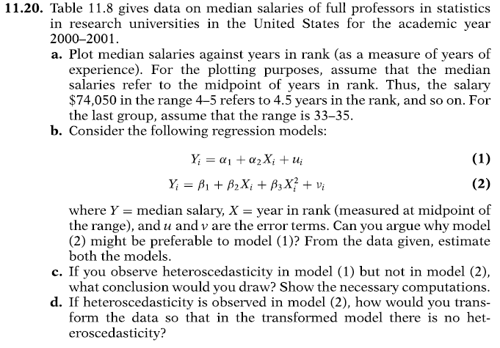

**Ans a:**

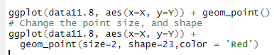

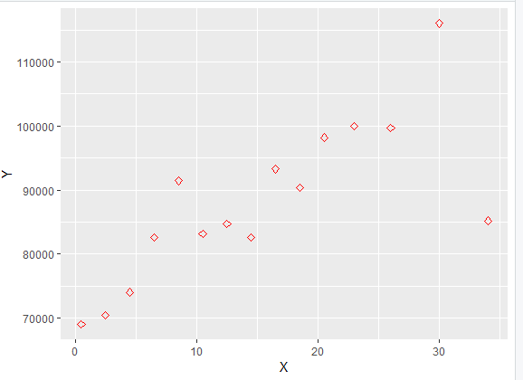

**Ans b:**

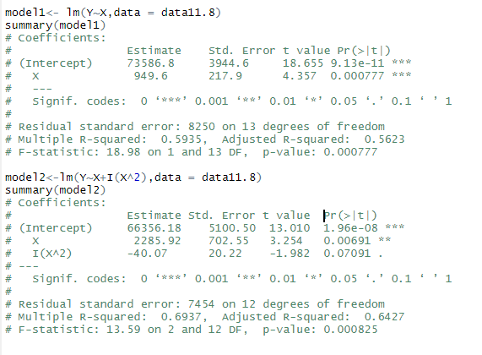

**R-squared value for model 2 seems to be much better than model 1. We will choose model 2.**

**Ans c:**

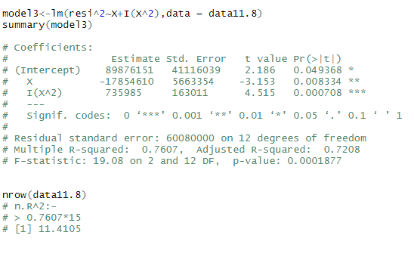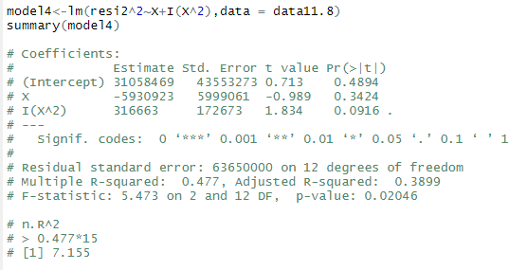

**If we perform White’s HDK test we can see in model 1 we get n.R^2 value as 11.41 with p-value as 0.0033 suggesting HDK is there.**

**In model2 n.R^2 value is 7.155 with p-value as 0.0538 suggesting no HDK.**

**Ans d:**

**If we try to divide model 1 by X and then perform White’s HDK test we do not observe any sign of HDK**

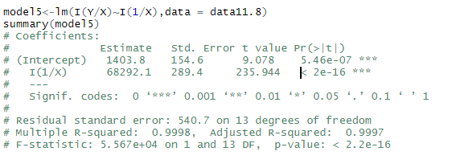



**A stochastic process is said to be weak stationary if mean, variance and autocovariances are constant over time.**

**The value of covariances depend on the lag between 2 periods and not on the actual time period at which covariance was computed.**



**If a (nonstationary) time series has to be differenced d times to make it stationary, that time series is said to be integrated of order d. A time series Yt integrated of order d is denoted as Yt ∼ I(d).**



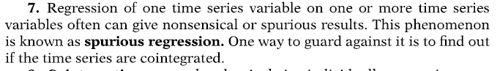



**If trends are predictable, they are deterministic otherwise stochastic.**

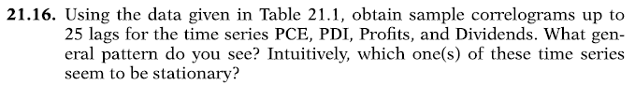

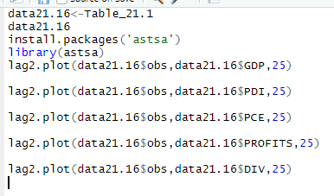

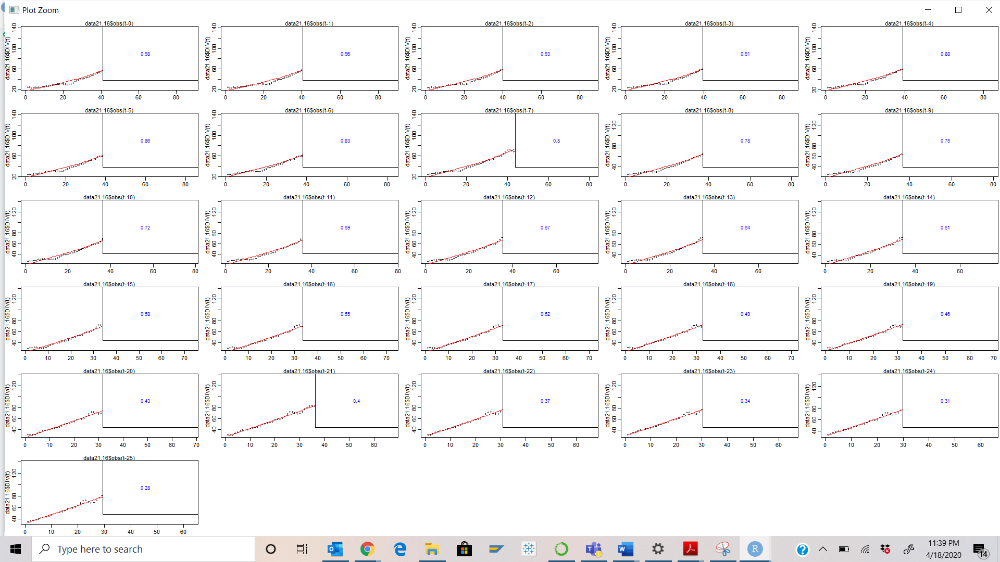

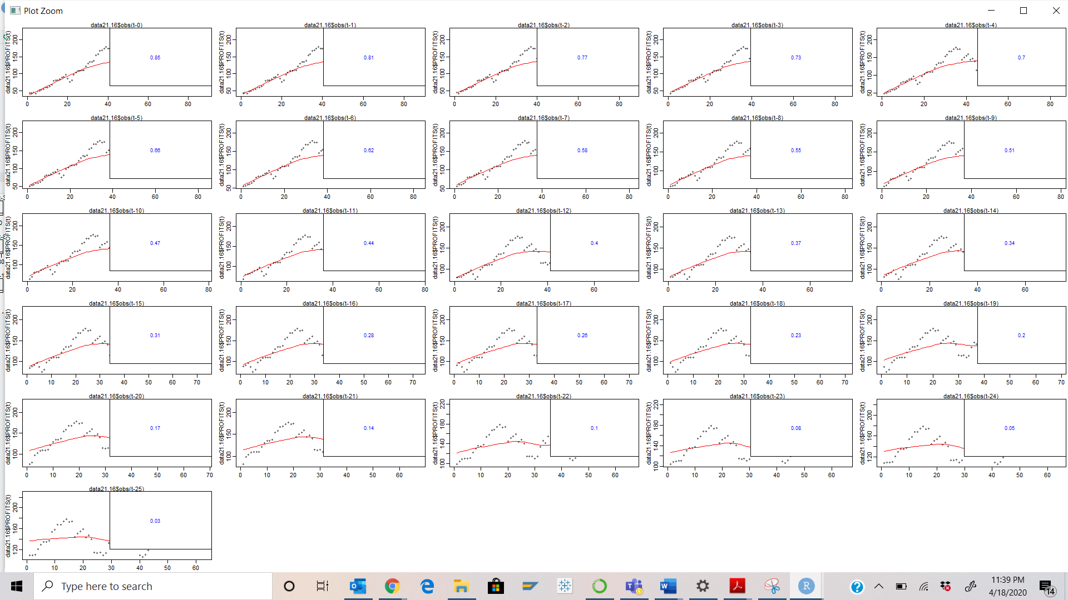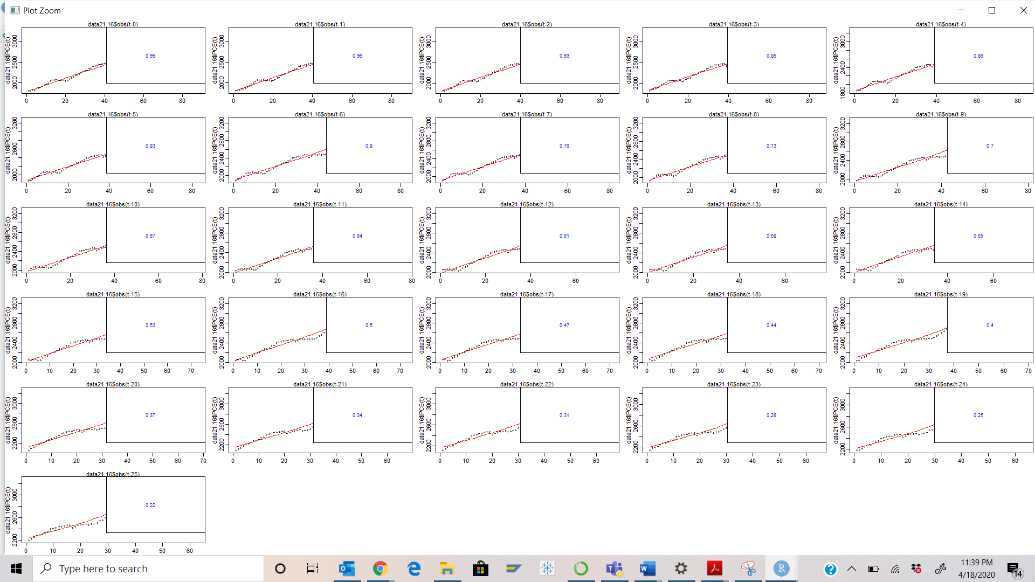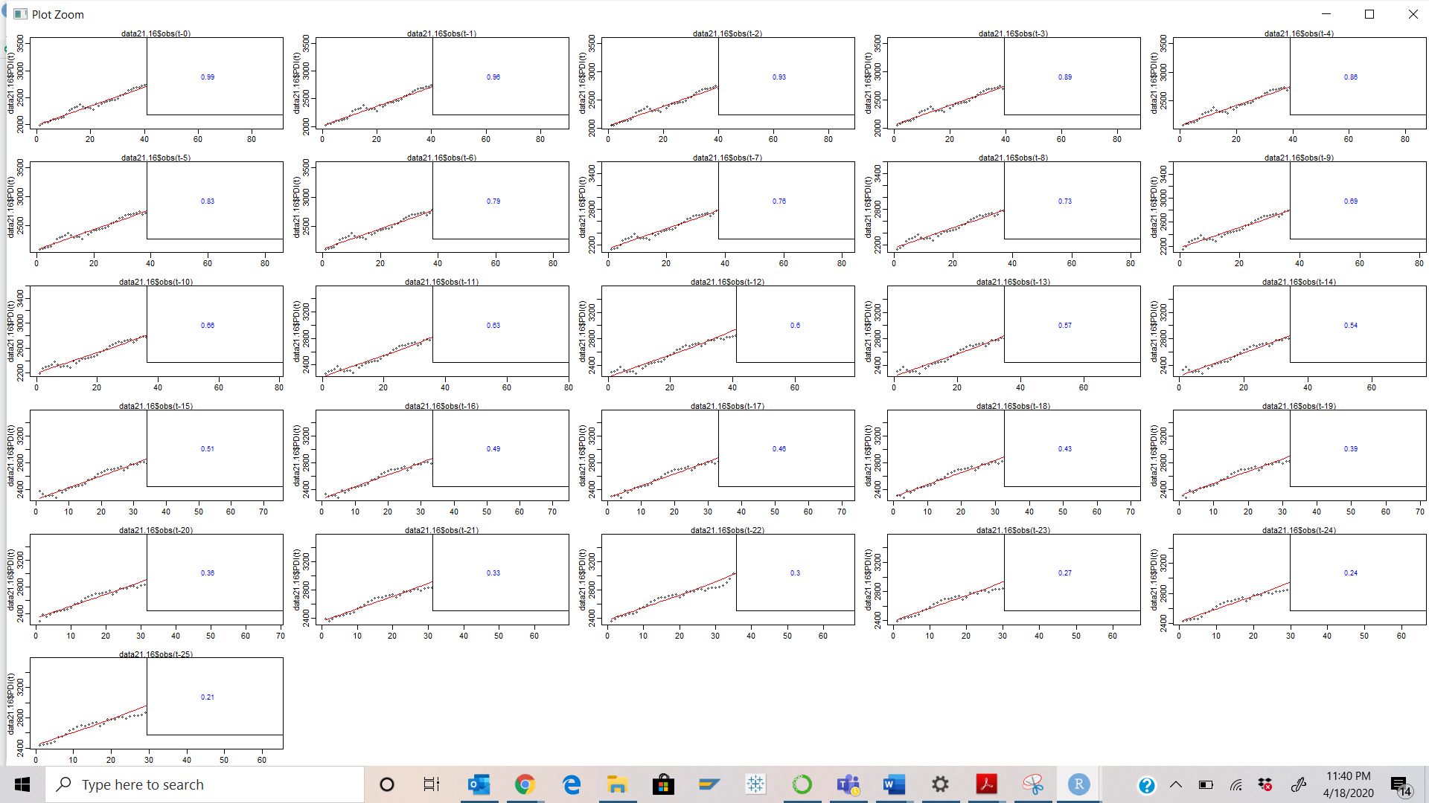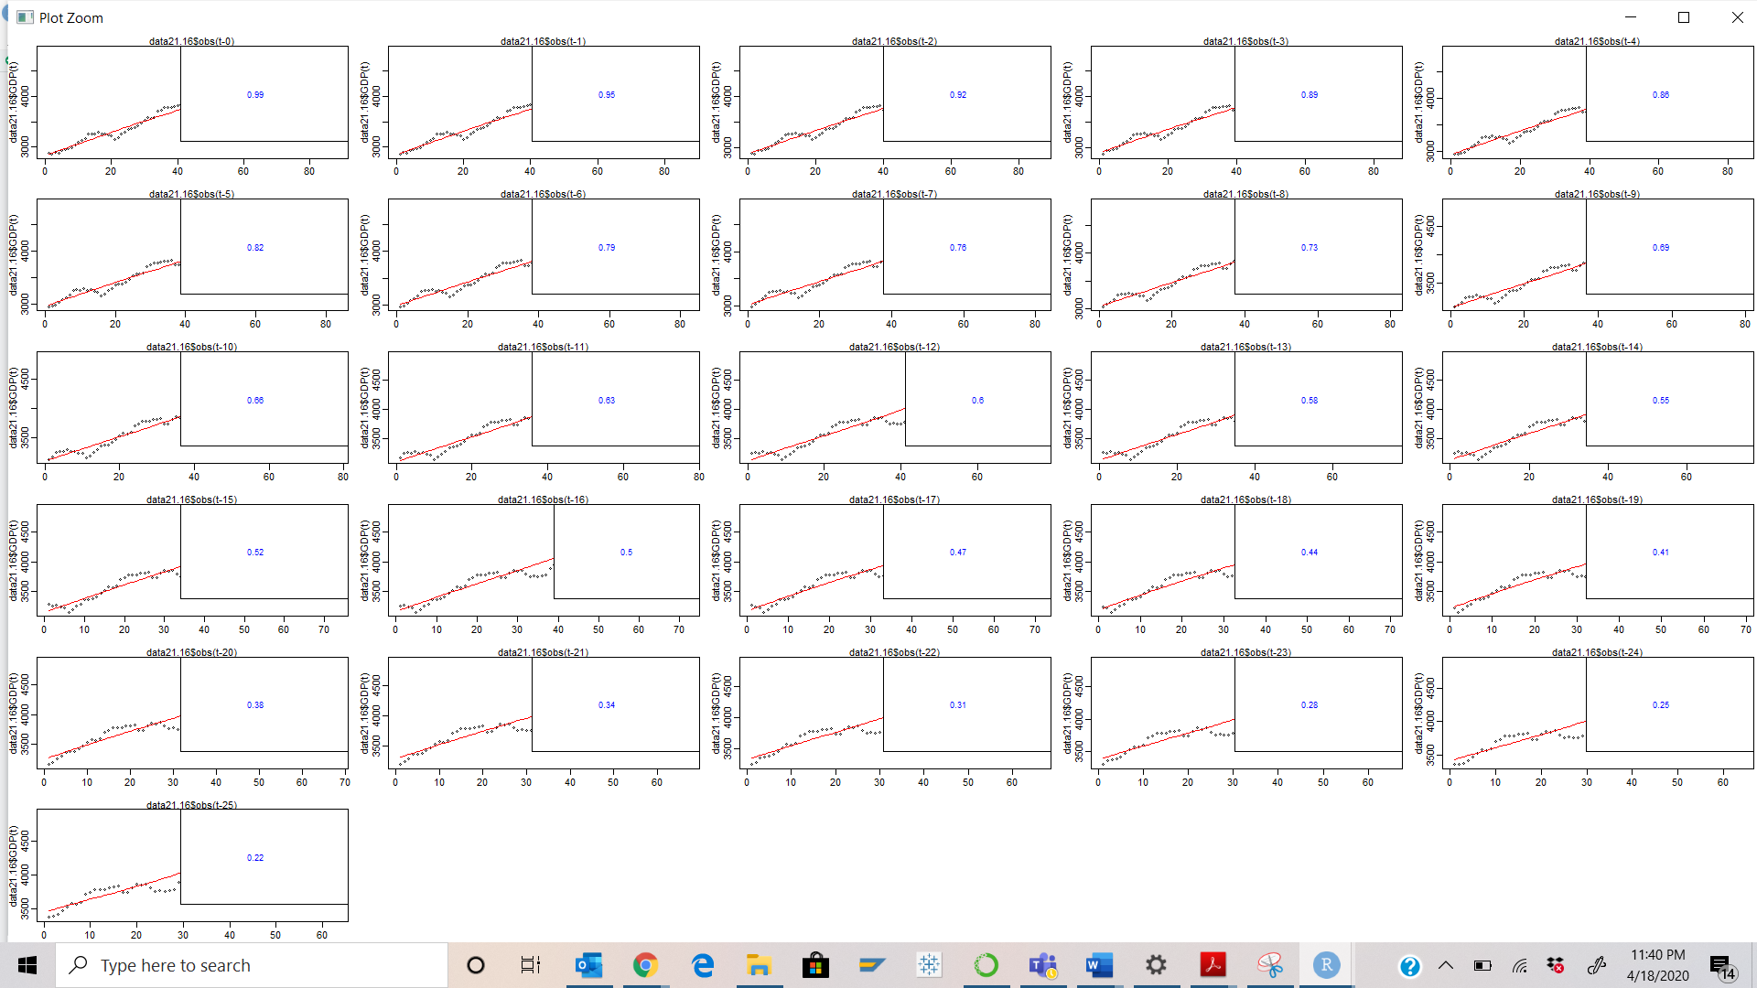

**All plots suggest that time series is non stationary.**



1. **identification**
2. **estimation**
3. **diagnostic checking**



**The results will seem to be unrealistic/unreliable.**

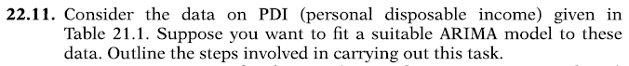

**Steps:**

1. **Check if time series is stationary or not**
2. **Check for ACF – Auto Correlation Function value**
3. **Check for PACF – Partial ACF**
4. **Examine residuals of the model**
5. **Check for white noise**
6. **If white noise is present – no action needed**
7. **Else search for white noise once again**
8. **Check for spike in trend at different lags**
9. **Fit Autoregressive model using intercept and lags**
10. **Check the regression results**